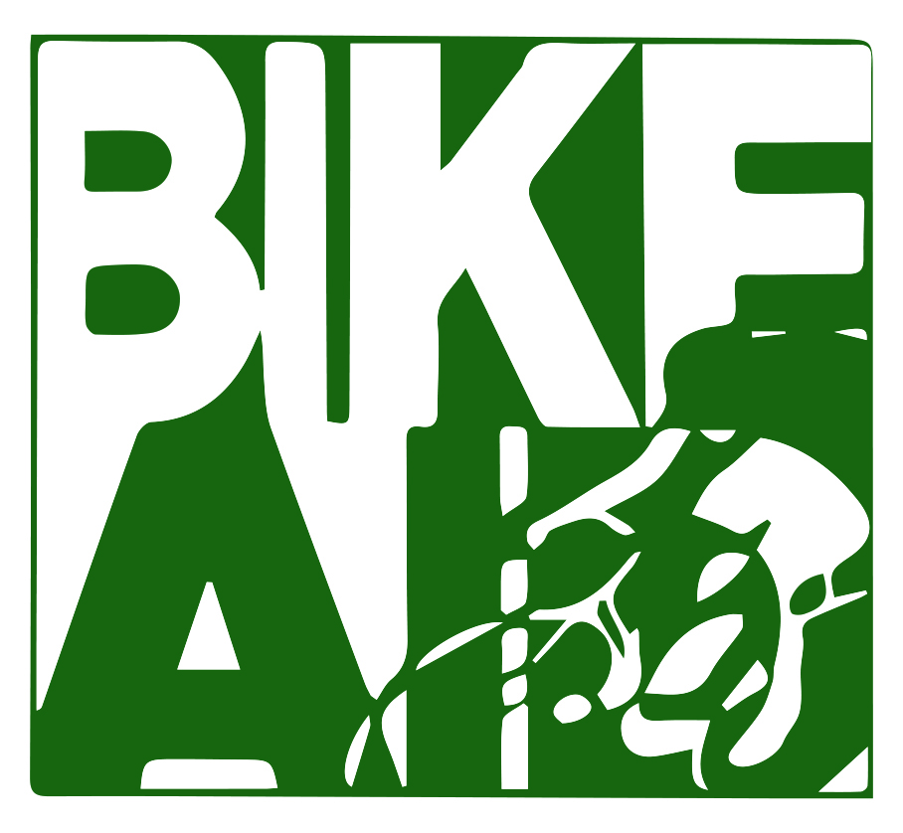

Bike Aid
The Cross Country Bikeathon for Global Development
215 Apple Blossom Ct, Vienna VA 22181
www.bikeaid.us 301-944-3370 info@bikeaid.us
________________________________________________________________________

Rider Information

Each person applying to become a Bike Aid rider needs to complete the Bike Aid Rider Application, and send it to riders@bikeaid.us All riders are required to fundraise in order to participate. All donations are tax deductible. The goal in 2022 is for each rider to raise $2 a mile. For cyclists participating in the entire cross country routes (Seattle, Portland, San Francisco and Los Angeles all ending in Washington DC) the goal is to raise $6000, as these routes are all approximately 3000 miles long. The minimum raised to participate is $1 a mile, which is $3000 for cross country riders.

Riders may participate for any length of time, from one day to the entire summer. In all cases, the goal of $2 raised per mile and minimum of $1 raised per mile is applied. For example, if a rider wanted to cycle for three days and those days covered 200 miles total, the rider would have a goal of raising $2/mile, or $400, with a minimum of $1/mile, or $200, to participate.

Riders should be in good physical condition and have a road bicycle, not a mountain bike. It is recommended that riders train before the event by cycling gradually more mileage a day until the rider can comfortably bike 70 miles a day. The average biking day on the ride is 65 miles, and days can range from 25 to 110 miles a day. Riders have a rest day about once a week. Each route has a support van which carries rider belongings, food, water, first aid kit and spare parts, which is driven in turns by the riders. For example, if there are 15 riders on a route, each rider will be expected to drive the support van once every 15 days of cycling.

Routes for 2022 | Dates | Days | Miles | Goal | Minimum
Seattle to Washington DC | June 14-Aug 10 | 56 | 3000 | $6000 | $3000
Portland OR to Washington DC | June 14-Aug 10 | 56 | 3000 | $6000 | $3000
San Francisco to Washington DC | June 14-Aug 10 | 56 | 3000 | $6000 | $3000
Los Angeles to Washington DC | June 14-Aug 10 | 56 | 3000 | $6000 | $3000
Austin TX to Washington DC | July 6-Aug 10 | 34 | 1950 | $3900 | $1950
Montreal to Washington DC | July 18-Aug 10 | 22 | 960 | $1920 | $ 960
Tallahassee FL to Washington DC | July 20-Aug 10 | 20 | 1070 | $2140 | $1070
Hawaii Island | Aug 6-Aug 10 | 4 | 220 | $440 | $220
Glenallen to Anchorage Alaska | Aug 7-Aug 10 | 3 | 180 | $360 | $180

Summary of each route

Seattle

The Seattle route is the northernmost route of Bike Aid, taking you through the states of Washington, Idaho, Montana, North Dakota, South Dakota, Minnesota, Wisconsin, Illinois, Indiana, Michigan, Ohio, Pennsylvania, Maryland, Virginia and Washington DC. You will climb the Rocky Mountains and Appalachian range, and pass through Glacier National Park and Native American reservations, as well as four state capitals: Helena MT, Bismarck ND, St Paul MN and Madison WI, where you may meet the governor to discuss climate change solutions in their state. You will also pass through the major cities of Minneapolis/St Paul, Milwaukee, Chicago, Pittsburgh and end in Washington DC, where you may meet the mayors to discuss climate change solutions in their city. You will also participate in several community service projects during rest days. The route has 47 cycling days and 7 rest days, 2 prep days in Seattle, and three days in Washington DC lobbying Congress to take action on climate change.

Portland, Oregon

The Portland route takes you through the states of Oregon, Idaho, Wyoming, Nebraska, Iowa, Illinois, Indiana, Ohio, West Virginia, Maryland, Virginia and Washington DC. You will climb the Rocky Mountains and the Appalachian range, and pass through Grand Teton National Park and Native American reservations, as well as four state capitals: Boise ID, Des Moines IA, Indianapolis IN, and Columbus OH, where you may meet the governor to discuss climate change solutions in their state. You will also pass through the major cities of Omaha, Chicago, Dayton and end in Washington DC, where you may meet the mayors to discuss climate change solutions in their city. You will also participate in several community service projects during rest days. The route has 47 cycling days and 7 rest days, 2 prep days in Portland, and three days in Washington DC lobbying Congress to take action on climate change.

San Francisco

The San Francisco route takes you through the states of California, Nevada, Utah, Colorado, Kansas, Missouri, Illinois, Indiana, Ohio, West Virginia, Virginia and Washington DC. You will climb the Rocky Mountains and the Appalachian range, and pass through Tahoe National Forest, Medicine Bow Route National Forest, as well as four state capitals: Sacramento CA, Salt Lake City UT, Denver CO and Topeka KS, where you may meet the governor to discuss climate change solutions in their state. You will also pass through the major cities of Reno, Ft Collins, Kansas City, St Louis and Cincinnati and end in Washington DC, where you may meet the mayors to discuss climate change solutions in their city. You will also participate in several community service projects during rest days. The route has 47 cycling days and 7 rest days, 2 prep days in San Francisco, and three days in Washington DC lobbying Congress to take action on climate change.

Los Angeles

The Los Angeles route takes you through the states of California, Arizona, New Mexico, Texas, Oklahoma, Arkansas, Tennessee, Virginia and Washington DC. You will cross the desert in the Southwest, pass through Petrified Forest National Park, climb the Appalachian mountain range, and visit three state capitals: Oklahoma City OK, Little Rock AR and Nashville TN, where you may meet the governor to discuss climate change solutions in their state. You will also pass through the major cities of Flagstaff, Albuquerque, Memphis, Knoxville, Roanoke and end in Washington DC, where you may meet the mayors to discuss climate change solutions in their city. You will also participate in several community service projects during rest days. The route has 47 cycling days and 7 rest days, 2 prep days in Los Angeles, and three days in Washington DC lobbying Congress to take action on climate change.

Austin TX

The Austin route is the southernmost route and takes you through the states of Texas, Louisiana, Mississippi, Alabama, Georgia, South Carolina, North Carolina, Virginia and Washington DC. You will pass through six state capitals: Austin TX, Baton Rouge LA, Montgomery AL, Atlanta GA, Raleigh NC and Richmond VA, where you may meet the governor to discuss climate change solutions in their state. You will also pass through the major cities of Houston, New Orleans, Charlotte and Chapel Hill, and end in Washington DC, where you may meet the mayors to discuss climate change solutions in their city. You will also participate in several community service projects during rest days. The route has 27 cycling days and 4 rest days, 2 prep days in Austin, and three days in Washington DC lobbying Congress to take action on climate change.

Montreal

The Montreal route starts in Canada and takes you through the states of Vermont, New Hampshire, Maine, Massachusetts, Rhode Island, Connecticut, New York, New Jersey, Pennsylvania, Delaware, Maryland and Washington DC. You will bike through the White mountains in New Hampshire, as well as six state capitals: Montpelier VT, Boston MA, Providence RI, Hartford CT, Dover DE and Annapolis MD, where you may meet the governor to discuss climate change solutions in their state. You will also pass through the major cities of Portland ME, New York City, Philadelphia and Wilmington, and end in Washington DC, where you may meet the mayors to discuss climate change solutions in their city. You will also participate in several community service projects during rest days. The route has 17 cycling days and 3 rest days, 2 prep days in Montreal, and three days in Washington DC lobbying Congress to take action on climate change.

Tallahassee extension to Austin route

The Tallahassee extension is a three day trip from Tallahassee FL that joins the Austin TX route in Columbus GA and takes you through the states of Florida, Georgia, South Carolina, North Carolina, Virginia and Washington DC. You will pass through four state capitals: Tallahassee FL, Atlanta GA, Raleigh NC and Richmond VA, where you may meet the governor to discuss climate change solutions in their state. You will also pass through the major cities of Charlotte and Chapel Hill, and end in Washington DC, where you may meet the mayors to discuss climate change solutions in their city. You will also participate in several community service projects during rest days. The route has 16 cycling days and 2 rest days, 2 prep days in Tallahassee, and three days in Washington DC lobbying Congress to take action on climate change.

Alaska

The Alaska route is a three day trip from Glennallen to Anchorage. After the 3 day event you will travel to Juneau where you may meet the governor to discuss climate change solutions in Alaska. The route has 3 cycling days, a day in Juneau, and an optional flight to Dulles airport, Virginia, where you will join a cross country route and bike one day into DC, and then spend three days in Washington DC lobbying Congress to take action on climate change.

Hawaii Island

The Hawaii route is a four day trip circumnavigating the Big Hawaii island in a clockwise direction, starting and ending in Kona, the home of the Ironman triathlon. The route continuously has the Pacific Ocean on one side and the towering volcanoes on the other, while requiring significant elevation gains and descents. After the 4 day event you will travel to Honolulu where you may meet the governor to discuss climate change solutions in Hawaii. The route has 4 cycling days, a day in Honolulu, and an optional flight to Dulles airport, Virginia, where you will join a cross country route and bike one day into DC, and then spend three days in Washington DC lobbying Congress to take action on climate change.

